1. What is the benefit of Microsoft 365?

Ans

[Office 365](https://core.co.uk/technology/office-365/) is Microsoft's productivity suite with tools like Word, Exchange, Excel, SharePoint, Teams and more. Because Office 365 is cloud-based, the full-featured experience can be accessed from anywhere, on any device, as long as they're online.

The tools in Office 365 complement each other and work together seamlessly, so it's a must-have for any business.

Here are seven key benefits of Office 365

**Access Files Anywhere**

Office 365 allows your organisation to store all the files in the cloud. This means they can be accessed on any device, from any location with an internet connection. For organisations where mobile working is essential, being able to access all the apps and files you need when out of the office is invaluable.

**Secure Cloud Storage**

Office 365 is a totally secure environment with robust security measures in place, like two-factor authentication, which ensures unauthorised people can't access your files if they happen to get on your device. Threat detection and anti-malware means security threats are identified and stopped immediately, which is particularly important for organisations that deal with confidential data or information. Using Office 365 means your business is free to operate without any concerns for security.

**Improved Communication**

Office 365 gives users tools to keep communication centralised and straightforward across Skype and Outlook. Skype for Business lets you hold conference calls and meetings with staff and external agencies anywhere in the world, so you can always collaborate and communicate regardless of distance or time difference. Teams provides an instant messaging function where comments can be added and files uploaded at the same time, which is useful for cross-department collaboration and when co-authoring documents. You can also 'at' people on Teams so they receive a notification that a comment is aimed directly at them. All these features mean you can be in constant and immediate contact with teams and individuals wherever they are located and at any time. Yammer is another feature of Office 365 which acts as a kind of social network for your organisation. By posting on your company 'news feed' you can instantly message the entire workforce, and staff receive an email notification when there is a new post so messages aren't missed. Anyone can comment on a post, and you can create different 'channels' in Yammer for different purposes, so you don't always have to post to the entire company.

**Predictable spend**

Office 365 is paid for on a per user, per month basis, like a subscription. The cost of your licences depends on the level of functionality you choose for your business. Different enterprise levels include different applications and products, which dictates the cost of each licence. Paying per user, per month gives you a predictable outgoing and helps you budget your IT spend for the year ahead. Upgrades are included in the cost of your licences, so there are no unexpected or additional costs. If you buy your licences through Core, you can also change the number of licence you have at any time, if you hire or people leave, for example. That way, you are never over-licensed and there is no waste.

**Business Continuity**

With files stored in the cloud and regularly backed up, your organisation continue to operate as normal in the case of a disaster at the office. No matter what happens to your physical devices, your email, files and data are safely stored in the cloud.  Exchange also has recovery features which mean individual emails or even entire inboxes can be restored if needed. No matter the situation, it can be business as usual if you're using Office 365.

**Automatic upgrades**

All the essential apps such as Word, Excel and Outlook are included and work online without the need to install any software. Upgrades are performed automatically at predetermined intervals, so you don't have to worry about being on the latest version; that will happen automatically. The expense of buying new software is also eradicated as updates are included in the subscription for your Office 365 licences.

**Centralised Collaboration**

Office 365 lets you share mailboxes, calendars, contacts and edit documents in real time through collaborative tools. Sharing calendars in Exchange means you can see who in your organisation is available when, so you can schedule meetings that work for everyone, first time round. Shared mailboxes mean multiple people can access the same mailbox, so messages can be filtered to land in the shared mailbox and won't be missed. SharePoint is another integral tool  for enabling collaboration. Documents that are saved here can be accessed and worked on by any staff member, and shared as a link in email.  Multiple users are also able to edit documents stored in SharePoint in real time, which makes co-authoring easy. You can see who is in the document at any time and even where they're working thanks to little coloured flags which identify each user.

2 . Use two datasets and perform join on specific columns

Ans

n this tutorial, you will find some tricks on merging Excel tables by matching data in one or more columns as well as combining worksheets based on column headers.

When analyzing data in Excel, how often do you have all necessary information gathered in a single worksheet? Almost never! It is a very common situation when different pieces of data are dispersed across many worksheets and workbooks. Fortunately, there are a few different ways to combine data from multiple tables into one, and this tutorial will teach you how to do this quickly and effectively.

If you are to merge two tables based on **one column**, [VLOOKUP](https://www.ablebits.com/office-addins-blog/excel-vlookup-tutorial/) is the right function to use.

Supposing you have two tables in two different sheets: the main table contains the seller names and products, and the lookup table contains the names and amounts. You want to combine these two tables by matching data in the Seller column:  
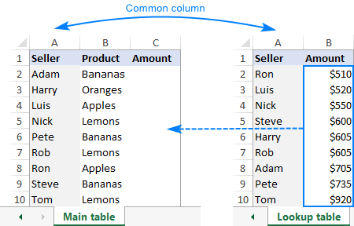

As you see, the order of the names in the main table does not correspond with that in the lookup table, therefore a simple copy/pasting technique won't work.

To combine two tables by a **matching column**(Seller), you enter this formula in C2 in the main table:

**=VLOOKUP($A2,'Lookup table'!$A$2:$B$10,2,FALSE)**

Where:

* $A2 is the value you are looking for.
* 'Lookup table'!$A$2:$B$10 is the table to search (please pay attention that we lock the range with [absolute cell references](https://www.ablebits.com/office-addins-blog/2015/11/25/relative-absolute-reference-excel/#Absolute-cell-reference)).
* 2 is the number of the column from which to retrieve the value.

Copy the formula down the column, and you will get a **merged table** consisting of the main table, plus the matched data pulled from the lookup table:  
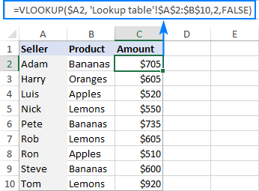

Please be aware that Excel VLOOKUP has several limitations, the most critical of which are 1) inability to pull data from a column to the left of the lookup column and 2) a hardcoded column number breaks a formula when you add or remove columns in the lookup table. On the bright side, you can easily reorder the returned columns simply by changing the number in the col_index_num argument.

**Tip.** If you have an Excel 365 subscription, then you can use a more powerful successor of VLOOKUP - [Excel XLOOKUP function](https://www.ablebits.com/office-addins-blog/excel-xlookup-function/).

### **How to merge tables in Excel with INDEX MATCH**

If you are looking for a more powerful and versatile alternative to the VLOOKUP function, embrace this INDEX MATCH combination:

**INDEX (return_range, MATCH (lookup_value, lookup_range, 0))**

The syntax is explained in detail in this tutorial: [INDEX / MATCH in Excel](https://www.ablebits.com/office-addins-blog/excel-index-match-function-vlookup/). And here I will show you how to use this formula to **look up from right to left**, something that VLOOKUP is unable to do.

Let's say you have another lookup table with order IDs in the first column and you wish to copy those IDs to the main table by matching the seller names. For better visualization, both tables are put on the same sheet:  
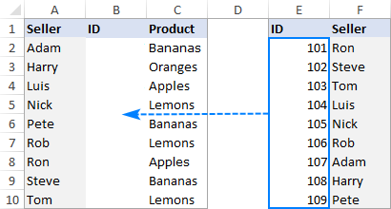

To accomplish the task, you supply the following arguments to the Index Match formula:

* Return_range­ ­- $E$2:$E$10
* Lookup_value - $A2
* Lookup_range - $F$2:$F$10

Please notice the $ sign that locks the ranges to prevent them from changing as you copy the formula down the table:

The completed formula looks as follows:

**=INDEX($E$2:$E$10, MATCH($A2, $F$2:$F$10, 0))**

…and combines data from two tables perfectly:  
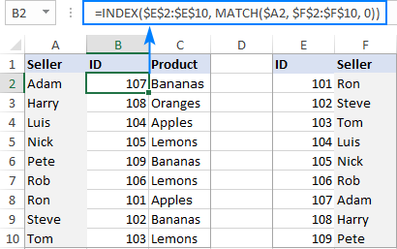

In Excel 365, you can use the new [XLOOKUP function](https://www.ablebits.com/office-addins-blog/excel-xlookup-function/) for the same purpose:

**=XLOOKUP(A2, $F$2:$F$10, $E$2:$E$10, "Not found")**

### **How to combine tables by matching multiple columns**

If the two tables you wish to join do not have a unique identifier, such as an order id or SKU, you can match values in two or more columns by using this formula:

**INDEX(lookup_table, MATCH(1, (lookup_value1=lookup_range1) * (lookup_value2=lookup_range2), 0), return_column_number)**

**Note.** It is an [array formula](https://www.ablebits.com/office-addins-blog/2015/02/25/array-formulas-functions-excel/), so please remember to press Ctrl + Shift + Enter to enter it correctly.

The formula's breakdown can be found here: [Look up with multiple criteria](https://www.ablebits.com/office-addins-blog/excel-index-match-function-vlookup/#lookup-multiple-criteria). For now, let's focus on the practical usage.

Assuming you have the following two tables to be combined into one. Because the Order ID column is missing in the lookup table, the only way to match the orders is by Seller and Product:  
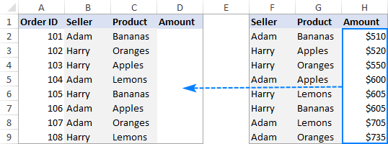

Based on the above screenshot, let's define the arguments for our formula:

* Lookup_table - $F$2:$H$9
* Lookup_value1 - $B2
* Lookup_range1 - $F$2:$F$9
* Lookup_value2 - $C2
* Lookup_range2 - $G$2:$G$9
* Return_column_number­ ­- 3

Again, be sure to fix all the **ranges** with **absolute cell references** so that they won't change when you copy the formula down:

**=INDEX($F$2:$H$9, MATCH(1, ($B2=$F$2:$F$9) * ($C2=$G$2:$G$9), 0), 3)**

Enter the formula in D3, press Ctrl + Shift + Enter, copy it to the below rows and check the result:  
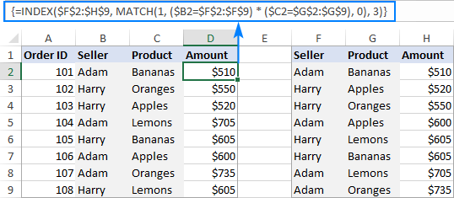

To have a closer look at the above examples and probably reverse-engineer the formulas, you are welcome to download our sample workbook to [Merge Two Tables in Excel](https://cdn.ablebits.com/excel-tutorials-examples/excel-merge-tables.xlsx).

## Join multiple tables into one with Excel Power Query

In situations when you need to combine two or more tables with different numbers of rows and columns, Excel Power Query may come in handy. However, please be aware that joining tables with Power Query cannot be done with a mere couple of clicks. Explaining all the nuances would take far more space than we have here, so I will just briefly outline the main features:

* Power Query can merge two tables by matching one or several columns.
* The source tables can be on the same sheet or in different worksheets.
* The original tables are not changed. The data is combined into a new table that can be imported in an existing or a new worksheet.
* In Excel 2016 and Excel 2019, Power Query is an inbuilt feature. In Excel 2010 and Excel 2013, it can be downloaded as an add-in.

3.How to perform string formatting in excel. Demonstrate it with examples.

Ans

# Formatting the Numbers in an Excel Text String

It’s not uncommon to have reporting that joins text with numbers. For example, you may be required to show a line in your report that summarizes a salesperson’s results, like this:

John Hutchison: $5,000

The problem is that when you join numbers in a text string, the number formatting does not follow. Take a look at the figure as an example. Note how the numbers in the joined strings (column E) do not adopt the formatting from the source cells (column C).

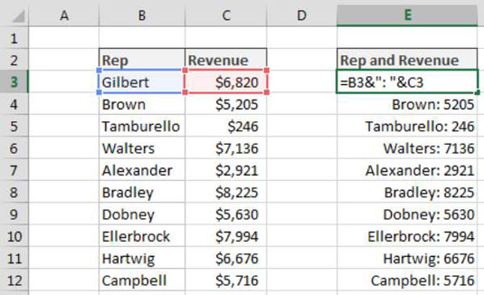

To solve this problem, you have to wrap the cell reference for your number value in the TEXT function. Using the TEXT function, you can apply the needed formatting on the fly. The formula shown here resolves the issue:

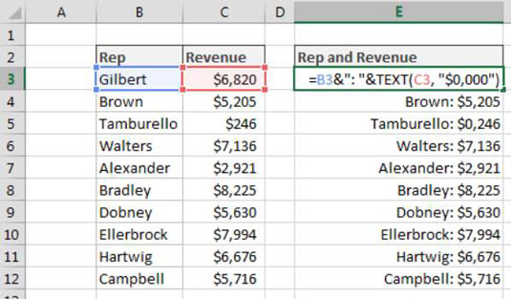

=B3&": "&TEXT(C3, "$0,000")

The TEXT function requires two arguments: a value, and a valid Excel format. You can apply any formatting you want to a number as long as it’s a format that Excel recognizes.

For example, you can enter this formula into Excel to display $99:

=TEXT(99.21,"$#,###")

You can enter this formula into Excel to display 9921%:

=TEXT(99.21,"0%")

You can enter this formula into Excel to display 99.2:

=TEXT(99.21,"0.0")

An easy way to get the syntax for a particular number format is to look at the Number Format dialog box. To see that dialog box and get the syntax, follow these steps:

1. Right-click any cell and select Format Cell.
2. On the Number format tab, select the formatting you need.
3. Select Custom from the Category list on the left of the Number Format dialog box.
4. Copy the syntax found in the Type input box.

4. Create an advance expense distributor in excel.

Example: Consider expenses of a person who will be entered in excel at the same time expenses must be evenly distributed among all people with the amount of money each person should return/ receive.

Ans

Excel IF AND OR functions on their own aren’t very exciting, but mix them up with the [IF Statement](https://www.myonlinetraininghub.com/excel-2007-%E2%80%93-if-statement-explained) and you’ve got yourself a formula that’s much more powerful.

In this tutorial we’re going to take a look at the basics of the AND and OR functions and then put them to work with an IF Statement.  If you aren’t familiar with [IF Statements, click here to read that tutorial first](https://www.myonlinetraininghub.com/excel-2007-%E2%80%93-if-statement-explained).

### **AND Function**

The AND function belongs to the logic family of formulas, along with IF, OR and a few others.  It’s useful when you have multiple conditions that must be met.

In Excel language on its own the AND formula reads like this:

=AND(logical1,[logical2]....)

Now to translate into English:

=AND(is condition 1 true, AND condition 2 true (add more conditions if you want)

### **OR Function**

The OR function is useful when you are happy if one, OR another condition is met.

In Excel language on its own the OR formula reads like this:

=OR(logical1,[logical2]....)

Now to translate into English:

=OR(is condition 1 true, OR condition 2 true (add more conditions if you want)

See, I did say they weren’t very exciting, but let’s mix them up with IF and put AND and OR to work.

5.Create reports to generate mark sheets of students in excel where percentages and addition of marks should be done using formulas.

Ans

## Marksheet Format in Excel

Whether it is any multinational company, small proprietorship, school or college, etc., every organization uses MS Excel to maintain their data and analyze the data for making decisions. For example, more than 1,000 students are in various standards and divisions. It is not easy to maintain their data manually in registers. That is why the management of schools uses MS Excel to keep students’ data. In the Excel mark sheet, we have to manipulate students’ marks in various ways to evaluate their performance and give the result.

#### #1 – **SUM Function**

To find out the total, we will use the **SUM**function

The syntax for the [**SUM in excel**](https://www.wallstreetmojo.com/sum-function-in-excel/) is as follows:



This function takes 255 numbers in this way to add. But we can also give the range for more than 255 numbers as an argument for the function, to sum up.

There are various methods to specify numbers as follows:

##### #1 – Comma Method

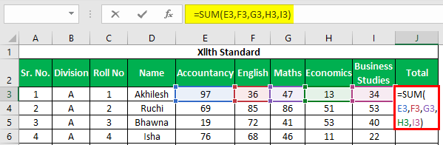

The total will be –

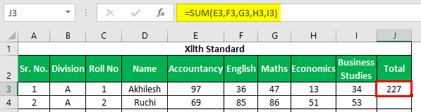

In this method, we use commas for specifying and separating the arguments. We have fixed or selected various cells with commas.

##### #2 – Colon Method (Shift Method)

In this method, we have used the “**Shift”** key after selecting the first cell (E3) and then used the right arrow key to choose cells until I3. We can select continuous cells or specify the range with the colon manually.

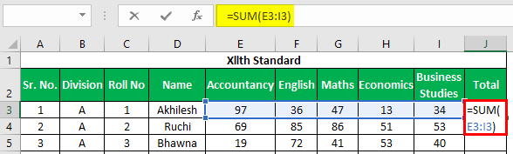

The total will be:

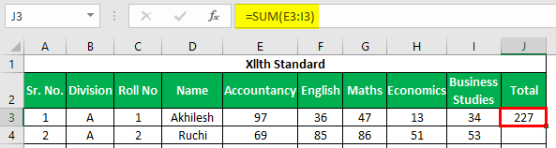

After entering the formula for the first student, we can copy the formula using **“Ctrl+D”** as a shortcut key after selecting the range with the first cell at the top to copy this formula down.

Apply the above formula to all the remaining cells. We get the following result.

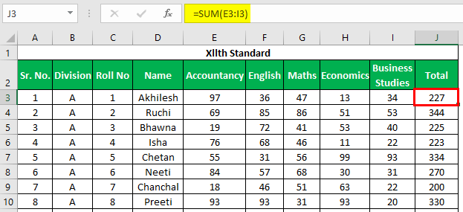

#### #2 – AVERAGE Function

For calculating average marks, we will use the **AVERAGE function**. The [**syntax for the AVERAGE function**](https://www.wallstreetmojo.com/average-function-in-excel/) is the same as the **SUM function**.

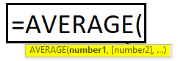

This function returns the average of its arguments.

We can pass arguments to this function the same way we pass arguments to the SUM function.

For evaluating the average in the excel mark sheet, we will use the **AVERAGE function** in the following way. First, we will select marks scored by a student in all five subjects.

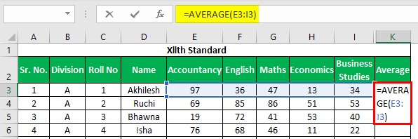

The average will be –

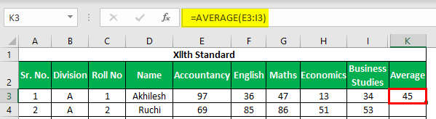

We will use **Ctrl+D** to copy down the function.

Apply the above formula to all the remaining cells. We get the followi 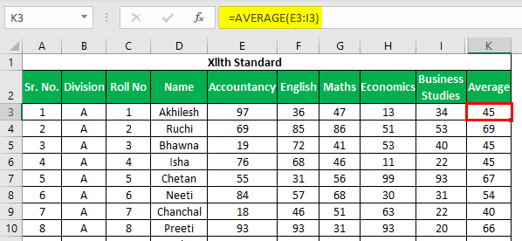 ng result.